*Florida International University*

*School of Computing and Information Sciences*

CIS 4911 - Senior Capstone Project

Software Engineering Focus

Feature Document

User Story #537

**Team Member:**

Andrew Mitchell

**Product Owner(s)**:

Francisco R. Ortega

**Mentor(s)**:

Francisco R. Ortega

...

**Instructor**: Masoud Sadjadi

# 

# **User Story – Implement Random Color Mode**

* As a User I would like to be able to Randomize the colors of the line I draw so I can use the multitouch and draw with many vibrant colors at once.

## **Use Case - Toggle Random Color Mode**

Use Case

Implement Random Color Mode

Details:

Actor: User

Pre-conditions:

Touch screen working.

Able to draw lines.

Program Running.

Description:

Use case begins when a user presses a key (‘r’, Temporary until design philosophy is completed). This will randomize the color of the next line drawn, as well as every subsequent line. The User can continue to cycle forward with ‘w’ and backwards with ‘q’.

The user story ends when the user successfully draws a line with a random color.

Post-conditions:

Line changes color randomly (may have to draw multiple).

Decision Support:

Frequency: Fairly often. Using a multi-touch will give incentive to have random colors for each different touch input.

Criticality: Low. More ways to paint on a canvas, but not too useful. Fun tool to show kids.

Risk: Low. Team member already knows how to change colors. Need to learn how to implement a random color.

Constraints:

Usability:

Just need to learn the proper keybinding.

Reliability: Very Reliable.

Mean time to Failure – Should only fail in extreme conditions. (Keyboard input overloads etc).

Availability – Always available (may change at a future date).

Performance:

Should occur right away.

Supportability:

Must work with ACER Multitouch.

Modification History:

Owner: Andrew Mitchell

Initiation date: 01/30/2016

Date last modified: 4/25/2016

## 

## Use Case Diagram

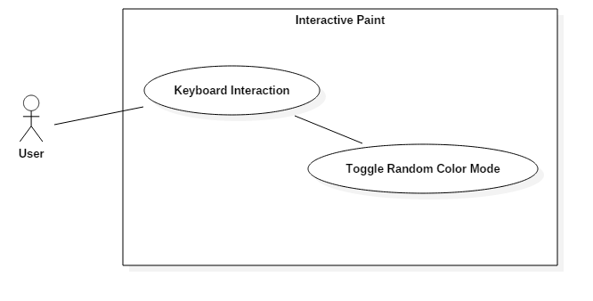

## 

## 

## 

## **Sequence Diagram**

## 

## **Class Diagram**

## C:\Users\IEatR\Pictures\Random Color Class.png

## 

## 

## 

## **Unit Test**

Sunny Day Tests

Test Case: Enable Random Color Mode

Test Purpose: Ensure that random color mode is randomizing colors

Test Setup:

1. Press ‘R’
2. Draw 4 lines with multitouch
3. Change shape
4. Draw 4 shapes

Test Output:

The 4 Lines had varied colors. The 4 shapes also had varied colors.

Expected Output:

The drawings, for the most part, should have varied colors. Though they can repeat once or twice, it is unlikely.

Rainy Day Tests

Test Case: Disable Random Color Mode

Test Purpose: Ensure that random color mode can be toggled off.

Test Setup:

1. Press ‘R’
2. Draw 4 lines
3. Press ‘R’
4. Draw 4 lines

Test Output:

The first 4 lines were of varied colors, while the next 4 were all black

Expected Output:

The first 4 lines should be different colors.

The following four lines should be all a singular color.

## 

## **Integration Test**

Currently integrated only with the keyboard (Can only be activated and de-activated with the keyboard).

The user can draw using random color mode using the leap motion device.

The user can draw using random color mode using the multitouch device.

The user can draw using random color mode using the real sense device.

The random color mode works for all shapes as well.

## 

## **User Guide**

Simply tap the ‘R’ key on your keyboard to enable random color mode.

After pressing ‘R’ Draw with whichever device or shape you want, and it will draw in random colors!

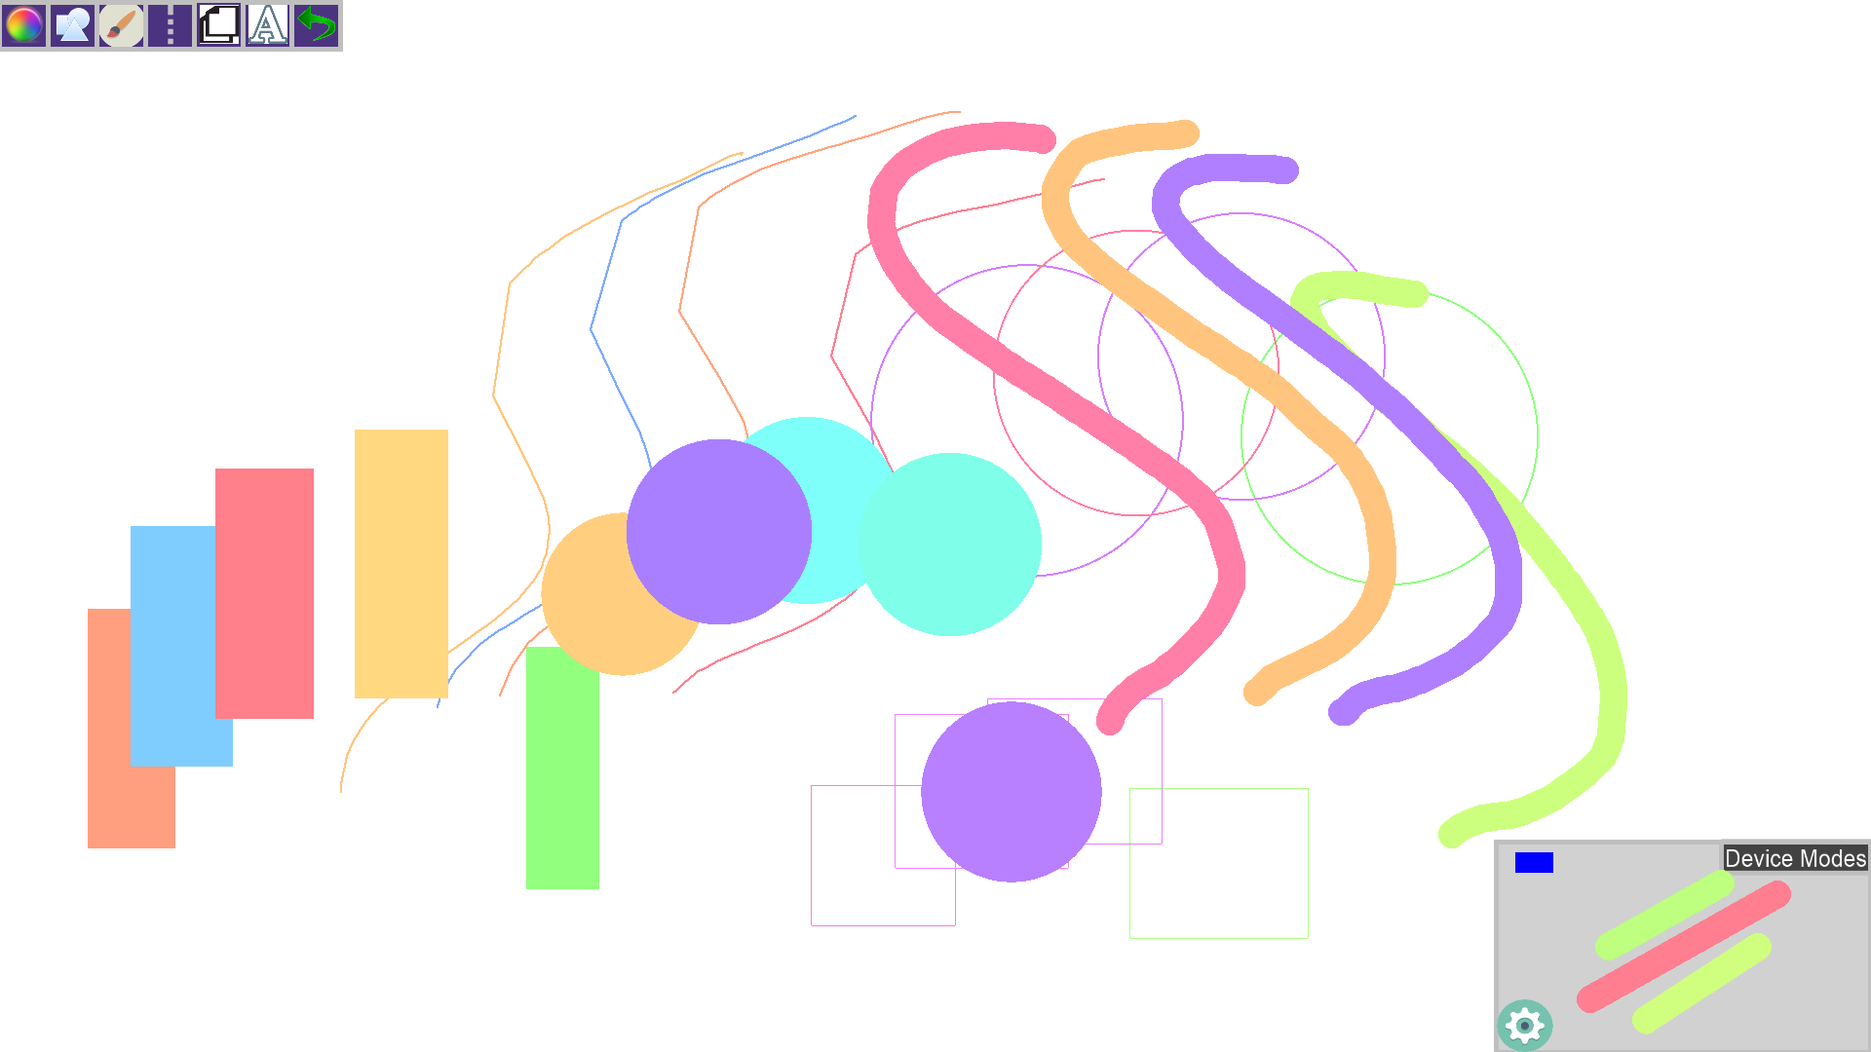

**Glossary**

Random Color Mode - A mode which randomizes colors instead of being static. Every new drawing has a different randomized color.